Guerra’s HOLIDAY

HOLIDAY FAVORITES

Prime Rib Roast | $18.99 lb.
New York Strip Roast | $18.99 lb.
Beef Tenderloin Roast (filet mignon) | $34.99 lb.
Diamond Jim Roast | $8.99 lb.
Leg of Lamb | $9.99 lb.
Crown Lamb Roast (18 chop minimum) | $10.00 per chop
Crown Pork Roast (18 chop minimum) | $10.00 per chop
Porchetta (5 lbs minimum) | $7.99 lb.
Old Fashioned Bone-In Ham | $6.99 lb.
Boneless Ham | $6.99 lb.
Fresh Diestel Turkey 6-30 lbs | $4.29 lb.
Diestel Heidi Organic Turkey 12-14 lbs | $5.99 lb.
Fresh Diestel Turkey Breast 4-10 lbs | $8.99 lb.
Duck 5lbs | $5.99 lb.
Goose 8-10 lbs | $20.99 lb.
Game Hen | $8.99 lb.
Guerra’s Meat or Vegetarian Lasagna 8-10 ppl | $70 ea.
Guerra’s Beef Ravioli (1 lb package) | $10 ea.
Guerra’s Veal Tortelli (1 lb package) | $10 ea.
Guerra’s Bolognese (pints &quarts) | $7/12 ea.

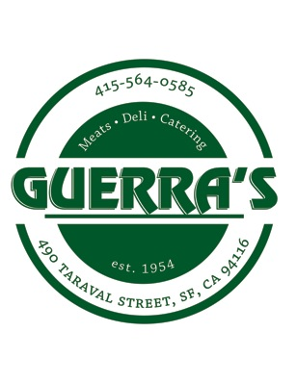 GUERRA’S WILL BE CLOSED MONDAY, DECEMBER 25 th

FULLY COOKED

Roasted Diestel Turkey small/med | $75/$100
Roasted 2 Rib Roast: serves 4-5 | $150
Roasted 3 Rib Roast: serves 6-8 | $225
Roasted 5 Rib Roast: serves 10-15 | $350
Roasted 7 Rib Roast: serves 15-20 | $500
Half Bone-In Ham: serves 8-10 | $85
Half Boneless Ham: serves 8-10 | $85
Bone-In Diestel Turkey Breast: serves 6-8 | $85

HAM or TURKEY DINNER

$195 Serves 12-14 people

12-14lb. Roasted Diestel Turkey or 4-5 lb Boneless Ham
5 lbs. mashed potatoes | 3 quarts stuffing |  | 1 quart gravy
2 cranberry sauce (15oz.) |  | 1 pumpkin pie or almond torte

Delectable Options

Guerra’s Porcini Demi Glace $10 /Dianda’s Almond Torte $23.99
Guerra’s Horseradish Cream Sauce $5 / Guerra’s Turkey Gravy $12
Guerra’s Stuffing $12 / Guerra’s Fresh Pasta / Guerra’s Tiramisu $12

Friday 22nd 9-6
Saturday 23rd 9-5 Sunday 24th 9-4 Christmas Day: CLOSED Tuesday 26th 9-5

Also carrying Liguria Italian Focaccia

